**Domain Model - College Jobs**

Users are able to set user preferences which contain notification prefs and job criteria. Job criteria is returned either from the database manager directly or returned from the search manager which returns to DBMgr and then to the user. The authentication manager must also return to the search manager before the search manager can be returned to the user through the database. The database also has access to the job listings which have access to the company information to be able to return all of that to the user. 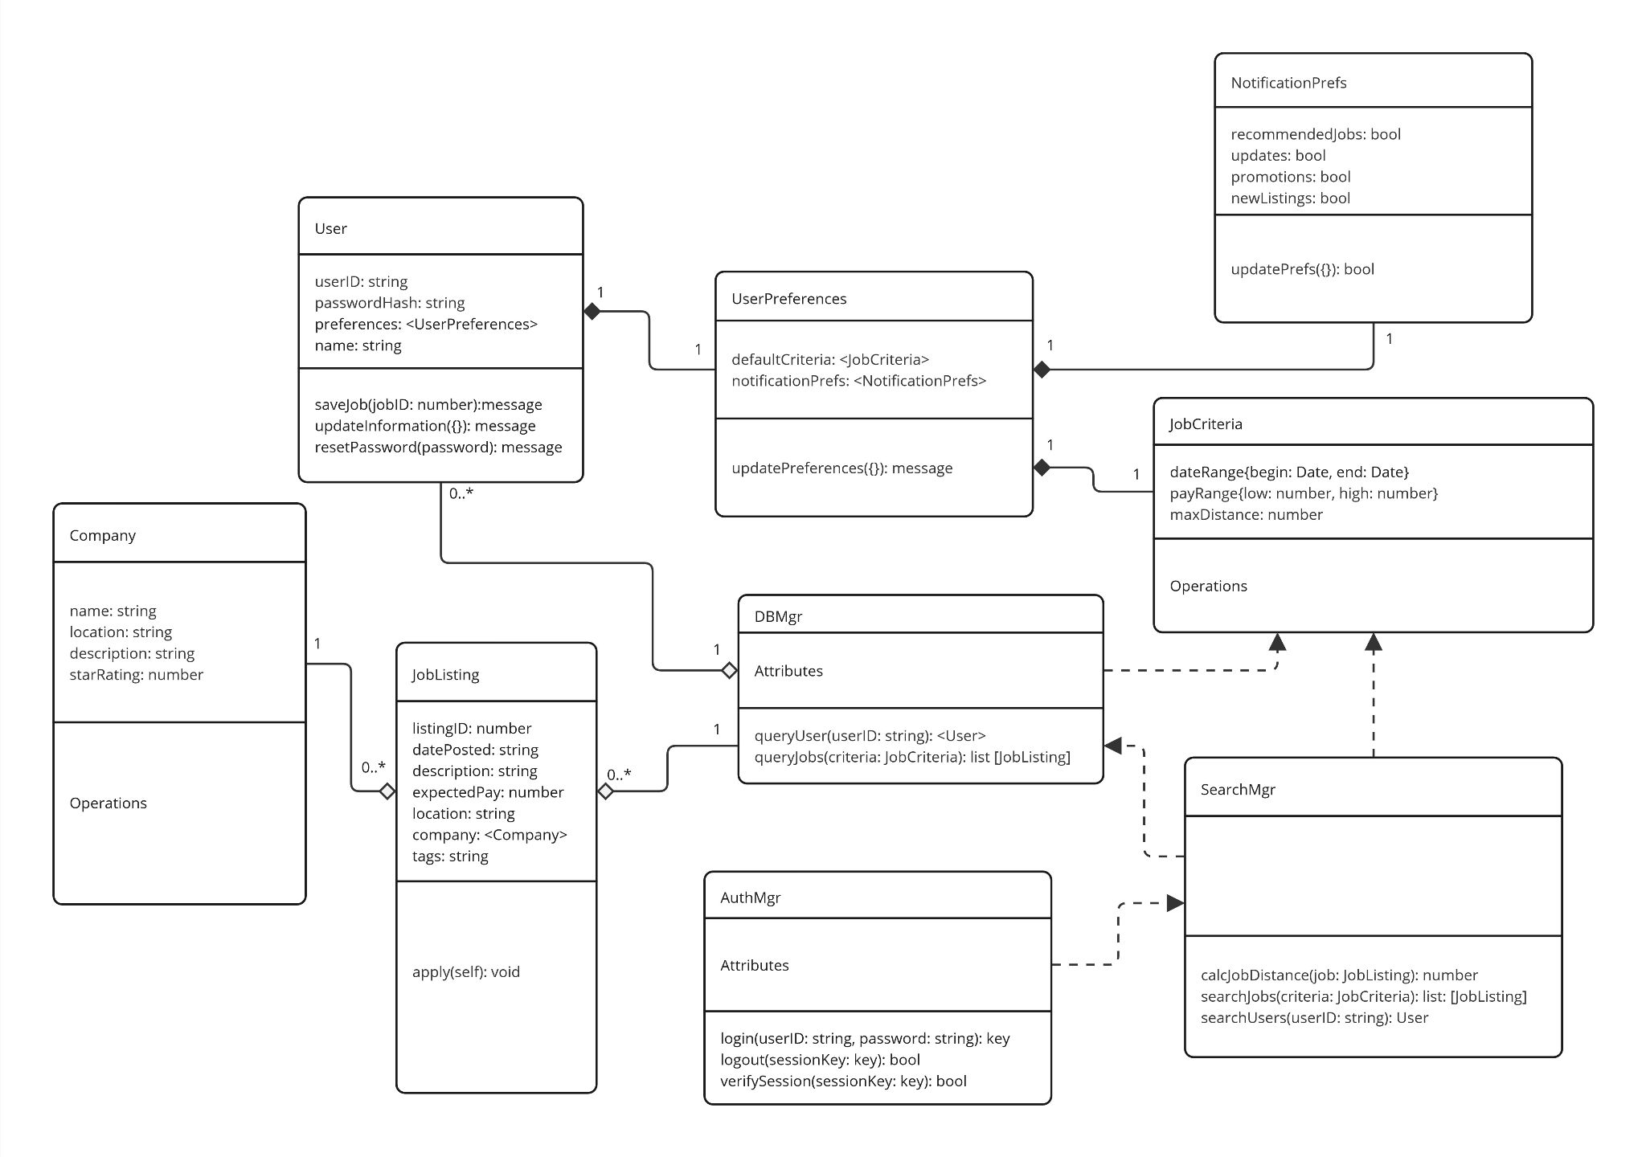

<https://miro.com/app/board/uXjVNP8F92I=/?share_link_id=56319358469>

Classes:

User

userID: string

passwordHash: string

preferences: <UserPreferences>

name: string

saveJob(jobID: number): message

updateInformation({}): message

resetPassword({}): message

UserPreferences

defaultCriteria: <JobCriteria>

notificationPrefs: <NotificationsPrefs>

updatePreferences({}): message

NotificationPreferences

recommendedJobs: bool

updates: bool

promotions: bool

newListings: bool

updatePrefs({}): bool

JobCriteria

dateRange{begin: Date, end: Date}

payRange{low: number, high: number}

maxDistance: number

JobListing

listingID: number

datePosted: string

description: string

expectedPay: number

location: string

company: <Company>

tags: string

apply(self): void

Company

name: string

location: string

description: string

starRating: number

AuthMgr

login(userID: string, password: string): key

logout(sessionKey: key): bool

verifySession(sessionKey: key): bool

SearchMgr

calcJobDistance(job: JobListing): number

searchJobs(criteria: JobCriteria): list: [JobListing]

searchUsers(userID: string): User

DBMgr

queryUser(userID: string): <User>

queryJobs(criteria: JobCriteria): list [JobListing]